



**BUS201: BUSINESS AND HUMAN COMMUNICATION**

A Term Paper on

**Salary Negotiation**

**Submitted by:**

**Section 08**

**Group 03**

Udoy Saha (21301095)

Abdul Khalek Alve (21301102)

Arittra Paul Ankur (21301101)

Samiya Khan Neha (21304007)

Fabiha Islam Promiti (20103046)

**Submitted to:**

Tarannum Khan Majles

Lecturer, BRAC Business School

BRAC University

**Date of Submission:**

7th April, 2023

**LETTER OF TRANSMITTAL**

April 7, 2023

Tarannum Khan Majles

Lecturer and Coordinator, Executive Programs & Industry Outreach

BBS, BRAC University

Mohakhali, Dhaka 1212

Subject: Submission of Business and Human Communication term paper on Salary Negotiation.

Dear Ms. Majles:

With all due respect, this is a wonderful opportunity to work on a Business and Human Communication term paper on "**Salary Negotiation**". We made sure to comply to both your instructions and your suggestions while writing this report.

Throughout the term paper, we attempted to include every possible situation associated with the topic. Moreover, we tried our best to add statistics and data from authentic sources along with examples from real life to make the work more engaging.

Thank you very much for helping us complete the term paper in a logical manner. We truly hope that the paper we wrote satisfies the requirements you set for us.

Yours sincerely,

Udoy Saha (21301095)

Abdul Khalek Alve (21301102)

Arittra Paul Ankur (21301101)

Samiya Khan Neha (21304007)

Fabiha Islam Promiti (20103046)

**CONTENTS**

1. Introduction 4
2. The significance of salary negotiation 4
3. Variables that affect salary negotiations 5
4. Strategies for successful negotiation 6
5. Tips for preparing for negotiation 7
6. Benefits of salary negotiation 9
7. Recommendations 10
8. Conclusion 11
9. References 12

**LIST OF ILLUSTRATIONS**

1. How salary negotiation helpsemployees to achieve a higher pay……………………… 5
2. Successful salary negotiation strategies ………………………………………………... 7
3. Actual salary range vs Unrealistic expectations ………………………………………... 8
4. The benefits achieved by Salary Negotiation …………………………………………... 9

# EXECUTIVE SUMMARY

Salary negotiation is a critical component of the job search process and is required for both job seekers and those looking to advance in their current careers. To guarantee that they are paid properly for their credentials and experience, employees must be aware of the principles of pay negotiating. The level of experience, education, talent, and the situation of the job market are the main factors that influence salary discussions. For job searchers to evaluate their worth and negotiate a salary that is commensurate with their education and experience, knowledge of these factors is crucial. However, some job searchers find it daunting and unpleasant to discuss their pay because they worry that if they do, they won't get the job. But salary negotiation results in better pay and more happiness, which can have a significant influence on a person's career as a whole. Employees should do their homework on compensation ranges and take non-salary perks into account when negotiating a raise. To raise confidence and improve communication skills, they could also engage in simulated negotiating sessions and practice efficient communication. When negotiating a raise, timing is important, and persuasiveness and confidence are required. Improved work-life balance, increased job satisfaction, and self-worth may all result from salary negotiations.

# INTRODUCTION

As salary negotiation may significantly affect a person's earnings and work happiness over the long term, it is an important part of the job searching process. It takes a certain level of creativity to properly communicate one's value to an employer and fight for fair pay. Salary negotiations are crucial for both job searchers and people trying to improve in their existing professions.

Many job searches in today's competitive job market are underpaid or undervalued because they lack the abilities and information to successfully negotiate their pay. So, it is essential for people to comprehend the foundations of pay bargaining to make sure they get paid fairly for their qualifications and expertise. The degree of experience, education, and talents as well as the state of the job market are some of the key elements that affect negotiations of compensation. Knowing these elements is essential nowadays, because it enables job searchers to assess their value and negotiate a compensation that is appropriate for their education and experience. However, some job searchers find it really intimidating and quite stressful to negotiate for their salary. Because, they have the fear in mind that they would not get the job if they negotiate for their salary.

The goal of this paper is to offer a thorough approach on salary negotiating. It will examine the significance of salary negotiations, the different factors that affect salary negotiations, and the tactics one may use to successfully bargain. By the time this report is finished, readers will know more about pay negotiations and have the knowledge and abilities needed to negotiate their compensation effectively, improving their financial situation and work happiness.

# THE SIGNIFICANCE OF SALARY NEGOTIATION

Negotiating salary has a huge impact on the overall career of an individual. Without negotiating for salary while the interviewing process, he/she might get the job but underpaid and undervalued by the organization. A study was done on 149 newly hired employees. The alarming outcome from the study was, individuals who engaged in salary negotiation undergone an average $5000 increase in their starting wage per annum (Marks & Harold, 2011). However, these people were somehow previously experienced. Another study was done on fresh graduates and the study showed similar results. It showed that the fresh graduated who negotiated for their salary experienced an average $1500 increase in their first wage of their life per annum (O’Shea & Bush, 2002). So, regardless of the persons total experience in the job field, salary negotiation works for all if a person knows the right tactics to do so. The following demographics will help us visualize the difference.

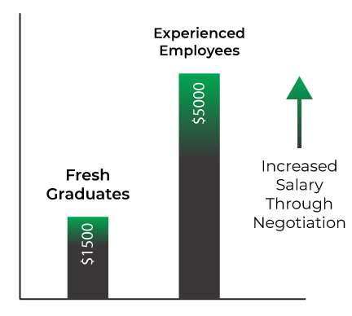

## **Figure 1**: How salary negotiation helps employees to achieve a higher pay

So, it is clear that, salary negotiation plays really significant role in one’s career. It has certain benefits, which are discussed in the later portion of this paper.

# VARIABLES THAT AFFECT SALARY NEGOTIATIONS

There are a few factors that affect salary negotiation. These are the key factors needed for a successful salary negotiation. These are:

* Proficiency on required skills
* Communication skills
* Understanding the basics of ethical professional negotiation (Wesner & Smith, 2019)
* Proper negotiation strategies
* Effective negotiating skills
* Market demand and situation
* Persistency

These factors really make a difference while negotiating for a salary raise. The following discussion inspects the effectiveness of these factors and how these can make difference in our salary negotiation process.

# STRATEGIES FOR SUCCESSFUL NEGOTIATION

There are some strategies for salary negotiation. If a person follows those strategies, there is a high chance that the person will successfully achieve a salary increase. According to a study published in Glassdoor (How to negotiate your salary, April 7, 2023), employees should consider the following strategies to effectively negotiate a salary:

* **Research salary ranges**: Employees should conduct research on the wage range for their position and experience level in their industry and geographic location before entering into negotiations. This can serve as a starting point for salary negotiations and assist workers in making a compelling case for a raise. Because, without prior research, one would not really know his/her actual worth and how much value he/she will be adding to the workplace or company.
* **Consider non-salary benefits**: One frequent blunder when discussing previous salaries is failing to include benefits as part of your total compensation. Employees should consider non-salary benefits such as health insurance, retirement programs, and vacation time in addition to salary. Besides, some companies offer their employees some amount of their company’s equity, which could be really beneficial for an employee in the long run. These benefits, which are frequently negotiated along with salary, can be of equal value.
* **Practice efficient communication**: Employees should be clear and concise about their salary expectations, and they should be prepared to explain the value they bring to the business. For this reason, they should practice their pitch at least once before the actual negotiation. A large part of an effective negotiation comes down to feeling at ease and practiced. A nice strategy could be practicing a mock negotiation session in front of a mirror or with a friend. It would boost their confidence as well as increase their communication skills.
* **Be persistent**: When negotiating for a salary, one needs to be very persistent. When one gets a rise of salary from a company or an organization, this increase also increases the total cost of the company. It is clear that a company would not like to increase its cost frequently. So, they might not give the salary increase on the first go. However, if a person is persistent with his/her application for a salary increase, the person will get that eventually by his/her attempts (Robertson et al., 2018).

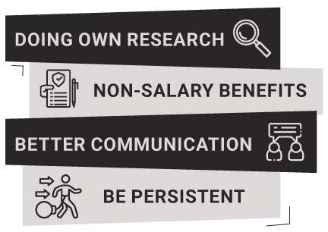

## **Figure 2**: Successful salary negotiation strategies

# TIPS FOR PREPARING FOR NEGOTIATION

We always need some preparation before doing anything. Salary negotiation is not different from those. There is always room for errors in every place, and through preparing we can shorten the room for errors. There are some basic rules while taking the preparation of a salary negotiation. Employees should prepare for the negotiating table by complying with the following rules of thumb:

* **Set rational expectations:** Employees should set reasonable expectations for their negotiation and be willing to compromise if needed. Setting unrealistic standards can lead to disappointment and resentment. For example, if there is a recession in the job market and someone is asking for an unrealistic high salary, he/she will certainly not get the job. Also, setting unrealistic salary expectation in a professional environment is very unprofessional and discouraged.

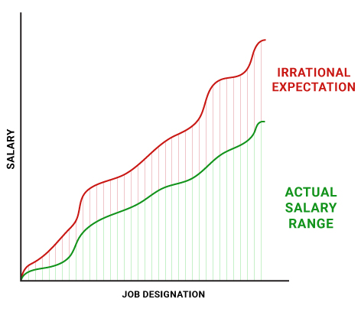

## **Figure 3**: Actual salary range vs Unrealistic expectations

* **Consider timing**: Even if it has been a while since the last raise, an employee must choose a good time to bargain for one and be prepared to make a case for a higher salary based on their experience and performance. There is always a chance to win something. If a person is experienced enough and has a good hold on his/her work area, the person will have a very high chance of winning a salary increase, if the person applies for it at the perfect time. So, the choice of timing is also really crucial. For example, if there is a senior position left blank in the company and an experienced person but in a junior position from the industry comes and takes the advantage of that time, he/she will prosper eventually.
* **Be firm and persuasive**: Confidence and persuasiveness are required for effectively negotiating a raise. A person must be able to persuade the employer or the HR department to get a raise in salary. However, the persuasion needs to be polite and professional. For example, letting the supervisor make the first offer is often beneficial (Wray and Williams, 2002).

# BENEFITS OF SALARY NEGOTIATION

There are several crucial benefits of a salary negotiation. Employees gain from salary negotiation in several ways (How to negotiate your salary, April 7, 2023), which include:

* **Improved job satisfaction:** If employees feel that they are being fairly compensated for their work, they may be more motivated and engaged in their employment. This can contribute to a greater feeling of fulfillment and job satisfaction. It would also increase their productivity and thus make the business profitable.
* **Improved work-life balance:** Negotiating higher pay can provide workers with the financial resources they need to achieve a better work-life balance, such as affording child care or taking time off for personal interests, affording time saving transportation services, etc.
* **Recognition of your value:** Negotiating your pay can also assist you in recognizing your worth as an employee. By asking for a higher salary, you're signaling your employer that you think you're worth more than the initial salary. This can boost your self-worth and show your value to your employer. In this way, an employee creates a bond with the company and gets the motivation to contribute more for the organization.

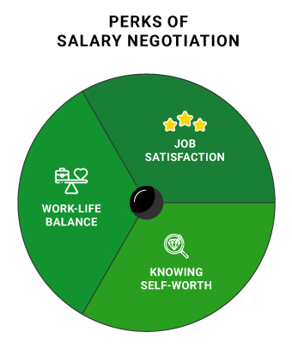

## **Figure 4**: The benefits achieved by Salary Negotiation

# RECOMMENDATIONS

While conducting our research on salary negotiation, we found out some really interesting facts and tactics for an effective salary negotiation. Based on our analysis, there are some recommendations we can have for the job seekers and the people who are aspiring to get a higher pay. Those are as follows:

* **Be expert about the work area in the first place**: When a company hires an employee, the basic motivation for the company is often bringing in expert people in their company and make maximum profit out of them with the least compensation possible. In this case, if a person is skilled enough about his/her job field, that person would very likely be hired. So, if a job seeker is experienced and skilled enough, it is easier for him/her to place the job and put an ask for a nice salary in front of the employers.
* **Be proactive**: We recommend that job seekers and employees adopt a proactive approach to salary negotiation. That means, the job seekers and employees should do their research beforehand about the salary ranges of the relevant job field and designation. After that, they might estimate their worth by comparing themselves with the people already working in their relevant job positions. From this, a person should have a clear negotiation plan which can help them get the job with a high salary.
* **Be smarter**: While taking the preparation of technical skills for any job, one should also prepare and develop soft skills within them. Some of the most required soft skills are communication skill, empathy and others. One should be really good at communication when he/she is negotiating for salary. The gestures, postures and eye contact are very crucial to look confident. Besides, self-practice on negotiation skill would add an extra advantage while salary negotiation. For this, preparing in front of a mirror would be the best task to do. And last but not the least, considering non-salary benefits while salary negotiation would be a really smart move.

If a person follows this recommendation, it can be said that the person is completely prepared for a salary negotiation and most likely would be employed with a high salary.

# CONCLUSION

In conclusion, salary negotiation is a complex and important process that requires preparation, strategy, and effective communication skills. Negotiating a salary can have a significant impact on one's career and earnings, and is therefore crucial for job seekers and employees to understand and master. This paper has provided an overview of the concept of salary negotiation, its importance, and the factors that influence negotiation outcomes. We have explored the psychological and social aspects of negotiation, the impact of gender and culture on negotiation, and the role of preparation and communication in achieving successful negotiation outcomes.

While there are difficulties and hurdles to good negotiating results, we think that job searchers and workers may overcome these difficulties and get just and equitable remuneration packages with the appropriate abilities and attitudes. In today's competitive employment market, pay negotiation continues to be a crucial factor in determining people's careers and quality of life. As a result, we urge more study and conversation on this subject.

# REFERENCES

Marks, M. C., & Harold, C. M. (2011, April 1). *Who asks and who receives in salary negotiation*. Journal of Organizational Behavior. <https://onlinelibrary.wiley.com/doi/abs/10.1002/job.671>

O’Shea, P. G., & Bush, D. R. (2002, March 1). *Negotiation for Starting Salary: Antecedents and Outcomes Among Recent College Graduates. Journal of Business and Psychology*. <https://link.springer.com/article/10.1023/A:1012868806617#citeas>

Wesner, B. S., & Smith, A. (2019, March 1). *Salary Negotiation: A Role-Play Exercise to Prepare for Salary Negotiation*. Management Teaching Review, 4(1), 14–26. <https://doi.org/10.1177/2379298118795885>

*How to negotiate your salary*. Glassdoor Career Guides. (n.d.). Retrieved April 7, 2023, from <https://www.glassdoor.com/blog/guide/how-to-negotiate-your-salary/>

Robertson, J., Williams, A., Maxwell, E., & Tait, A. J. (2018). *Salary negotiation*. In J. Robertson, A. Williams, D. Jones, L. Isbel, & D. Loads (Eds.), *EqualBITE: Gender equality in higher education* (pp. 136–139). Brill. <http://www.jstor.org/stable/10.1163/j.ctv2gjwtzk.35>

Wray, R., & Williams, R. (2002). *Professional Development: Negotiating a Salary. The American Journal of Nursing*, 102(2), 71–73. <http://www.jstor.org/stable/3522795>